WEST LONDON WASTE AUTHORITY
Report of the Projects Director | 22 March 2024
Waste composition analysis report
This report provides an update on the WLWA residual waste composition analysis and the impacts and opportunities arising from upcoming legislative change.
- Extended Producer Responsibility (EPR) will impact on c.25% of the material in residual waste. This is likely to drive material and design change and provides Boroughs and WLWA an opportunity to invest the EPR revenue in additional capture solutions.
- The Emissions Trading Scheme (ETS) poses a significant risk to the cost of residual waste treatment with the primary fossil derived materials being non-recyclable composites, textiles, plastics and e-waste.
- Capture rates for the main collected recycling systems are generally flat or falling slightly.

RECOMMENDATION(S)
- The Authority is asked to note the information within this report.

- Introduction
The 2023 waste composition analysis has been completed by Integrated Skills Ltd (ISL). The sampling of the residual waste took place during December. To ensure consistency of methodology ISL also revisited the data from previous waste composition analysis so that we have a consistent dataset.
Officers are working with ISL and Boroughs to establish the service context for the results and opportunities arising for improvements in capture and data.
WLWA Average composition detailed in Appendix 1.

Food waste, Green waste and dry mixed recycling in the residual waste
The data from the waste composition analysis shows that c.60% of the waste collected in residual waste containers across the area have alternative household collections available through Food waste, Dry Mixed Recycling (DMR), Green waste and on demand textile/e-waste collection services.
The Strategic Priorities for WLWA and the Boroughs as detailed in the Joint Municipal Waste Management Strategy section are supported by the data in the Waste composition.
- Food waste is still the greatest single volume stream in the residual waste and has an existing capture network. Given the difference in costs to treat the streams this supports a savings based approach to the food waste focus.
- Textile waste is still a significant contributor to the embodied carbon in our waste and supports the consumption reduction and increased capture approach in our priorities.
- Plastic waste falls into both recyclable and the NRC (non-recyclable combustible). Given the high levels of fossil carbon in these materials along with textiles this supports the risk based approach to managing the Emissions Trading Scheme through action on these materials.
- E-waste, whilst a smaller proportion on the waste overall offers a significant opportunity for reuse and repair, helping deliver local social value, training and jobs.

The graphs below indicate the efficacy of the services provided. This is a function of the public engagement with the service and the type/quality of service provided. It is important to note that the waste comp is taken every 15 months to include seasonality over the long term. Early results indicate that seasonality is a factor of all types of recycling but to different degrees.

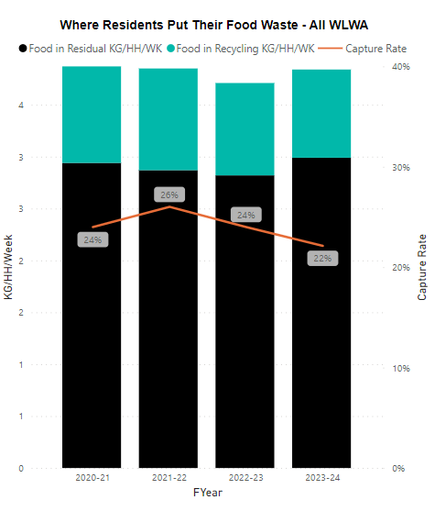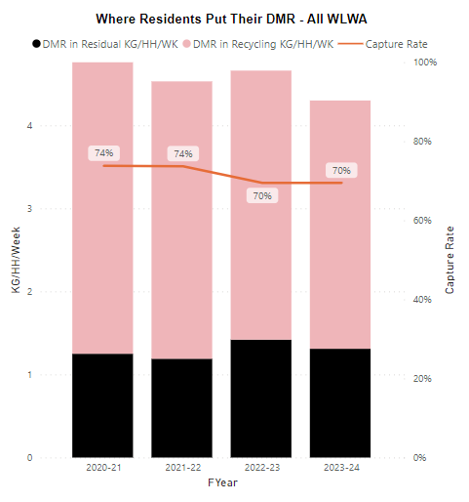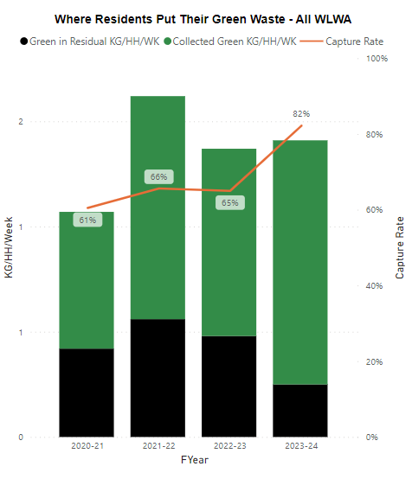
WLWA average residual composition is detailed in Appendix 1.
Table 1 – Capture rates and proportion of residual

 | (%) of gross volume captured | (%) of gross volume remaining in residual | (%) of residual
Food | 22% | 78% | 35%
Dry Mixed Recycling | 70% | 30% | 16%
Garden | 82% | 18% | 3%
Food waste – Total food waste has increased 7% compared to previous composition analysis results, and the capture rate has dropped.
Garden Waste – is highly seasonal in the effects on the waste composition, with this analysis completed in winter therefore trends are harder to identify.
Borough specific performance on capture and yield can be seen in Appendix 2, 3 and 4.
WEEE – The composition analysis shows the continuing trend for waste electricals (1%, c.3,500 tonnes) are being disposed of in the residual waste. This poses a significant risk to Borough and WLWA operations through fires caused by batteries and capacitors in waste electricals.

- Future system impacts: Extended Producer Responsibility and Deposit Return Scheme systems
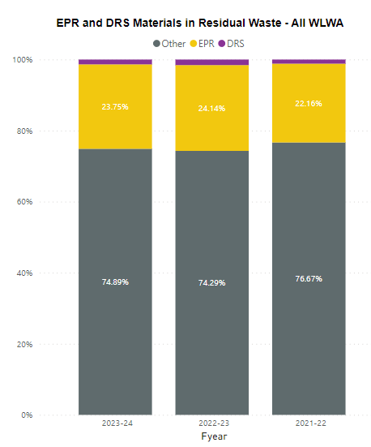
The overall proportions of the waste composition show that on average c. 25% of material disposed in residual is in scope of EPR and DRS systems for the past three financial years.
This material will be targeted by producers as leakage material from collections system and therefore most likely to change in the design, materials used and customer recycling information provided.
WLWA and the Boroughs have an opportunity to invest the income generated from the EPR payments to help improve infrastructure and services.
- Embedded Carbon
The different materials in waste have been historically measured on a tonnage (mass) basis. This approach doesn’t factor in the variability of the embodied carbon within the different materials, for example a tonne of textiles has a Carbon equivalent of c.23tonnes CO_{2(eq)} vs one tonne of glass at c.0.85tonnes CO_{2(eq)}.
The charts below depict the composition of the waste based on the CO_{2(eq)} basis rather than tonnage (mass).
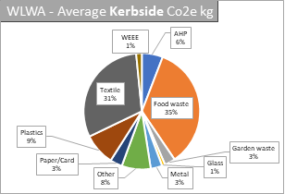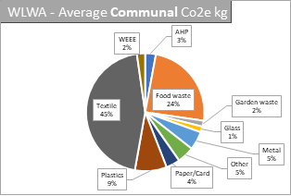

The overall proportions show that on average Textile, Food waste and Plastic account for more than 75% of average carbon embedded emissions in the residual waste and in targeting Net Zero should form the priorities for target materials.
- Emission Trading Scheme (ETS)
The Emissions Trading Scheme is based on the fossil carbon within the waste. This is not the same as the embodied carbon equivalent above and is measured on a tonnage (mass) basis.
The primary materials containing fossil carbon are textiles and plastics including e-waste. It is estimated that c.70% of the textiles produced are synthetic and fossil derived. This proportion means that the textiles will, on current volumes be a greater ETS cost at c.4.2% of the fossil derived waste than recyclable plastics at 4%.
The Non-recyclable Combustible (NRC) proportion (23%) of the residual waste is likely to contain the greatest proportion of fossil carbon but further breakdown is required.
This represents a significant financial risk under ETS scheme from 2028 and it underlines the immediate urgency with improving capture as a priority in addition to free textile home collections through our partnership with TRAID.
- Risk
Risk | Mitigation | Owner | RAG
Emissions Trading Scheme (ETS) costs of fossil carbon through Energy Recovery | Fossil Carbon materials effectively captured (Textiles, plastics, E-waste) | Boroughs/WLWA | Red
E-waste/waste electricals (WEEE) causes increase in frequency of fires | Alternative collections for capture and Communications for public engagement | Borough/WLWA | Amber
Continuing high volume of materials and embodied carbon | Capture of food waste and investment in continuous improvement of the food services. (Capital and revenue) | Borough/WLWA | Amber
- Financial Implications –
The Emissions Trading Scheme will be brought in to cover waste plants from 2028 and will levy an additional cost of c. £18 million per annum at the current volume and composition. This equates to £3 million per borough, per year and will need to be factored in to Borough medium term plans.

The Emissions Trading Scheme will be levied against fossil carbon products such as soft plastics, textiles and e-waste. Our ability to segregate fossil based plastic is currently only through resident engagement with kerbside and communal collection dry mixed recycling services. To mitigate the potential impact and ensure we have the requisite capacity we need to design and invest in infrastructure to segregate effectively in new facilities capable of sorting material and retaining value locally where possible. If we don’t develop our infrastructure, the additional money will simply go to funding penalties, not creating a solution.

The capture services and waste sites require change, our infrastructure is struggling with capacity across Borough transfer stations, HRRCs and collection services with recycling volumes set to double if we are to meet 65% recycling targets. More segregation of materials and more sorting will be required to extract specific streams to divert away from residual waste such as plastics and textiles.

There is also a risk associated with the fossil content of residual waste charges being traded as this could see the charge from the Emissions Trading Scheme fluctuate considerably. Early commentary is stating that this charge could vary by up to £10 million each year dependent on the market value of carbon credit. The Authority has set aside sums to build up against this fluctuation should fossil carbon in residual not decrease.

- Staffing Implications – None
- Health and Safety Implications – None
- Legal Implications – None
- Implications for the Environment Directors
The programmes are a key element in delivering the Environment Directors priorities in the next two years. The four priorities are shown below, supported by examples:
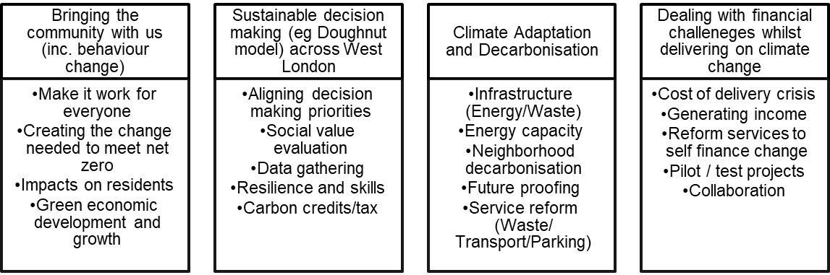
Key areas include behaviour change, data gathering, resilience and skills, social value evaluation and future proofing the system.
- Joint Waste Management Strategy
A key factor in the Joint Waste Management Strategy is the 65% recycling target. To meet this a framework of a joint plan for 2030 to be developed by WLWA and Boroughs was agreed in March 2022. The joint plan must incorporate managing the rising cost of inflation which can only be countered in WLWA by reducing the amount of waste collected.
It is vital in this year that we:
- Increase the proportion of residents using the food waste service and
- Prevent waste at source in the recycling centres.
The agreed framework is shown below:
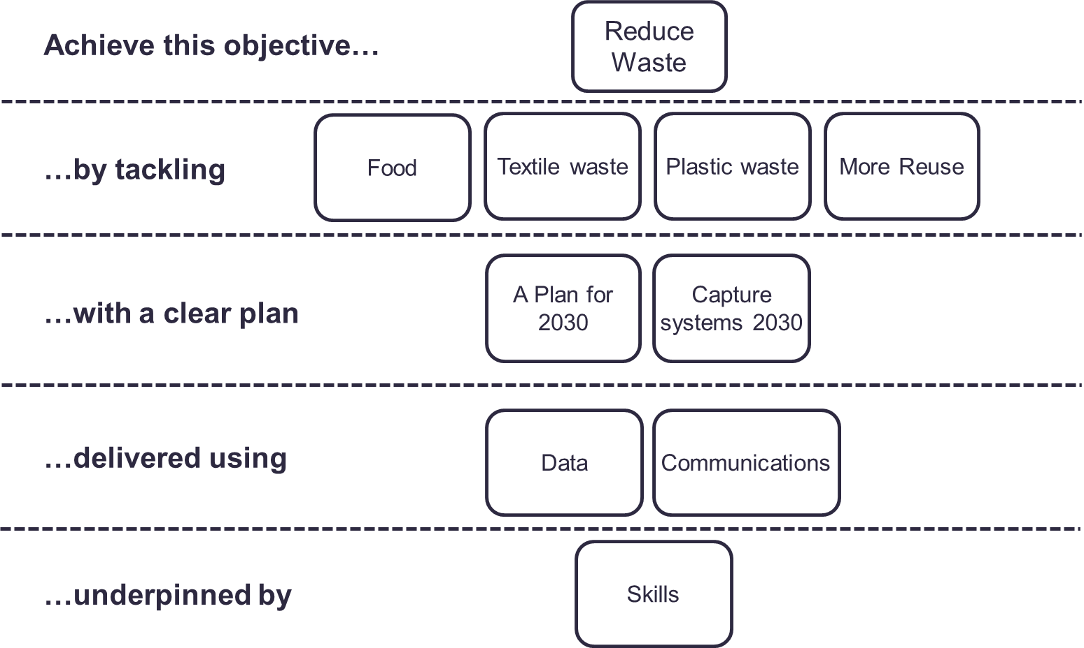
The programmes are intrinsically linked to the Authority’s Joint Waste Management Strategy and Business Plan. The projects are driving the design of the new policies and programmes through data, best practice and identification of opportunities, as well as delivering change to meet the desired outcomes and targets in the Strategy and the proposed Budget.
- Impact on statutory, national and London targets
Improvements in capturing greater volumes of target materials helps towards the target of 65% recycling by 2035 (2030 in London).

Contact Officers | Peter Tilston, Projects Director 07796 271 713  petertilston@westlondonwaste.gov.uk

Appendix 1 – WLWA average waste composition

*NRC (non-recyclable combustible) material is typically composite hard to recycle materials.
Appendix 2 – Borough capture rates – Food waste 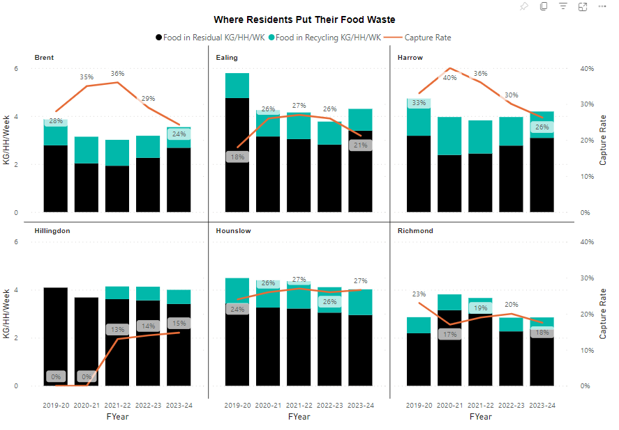Appendix 2 – Borough capture rates – DMR
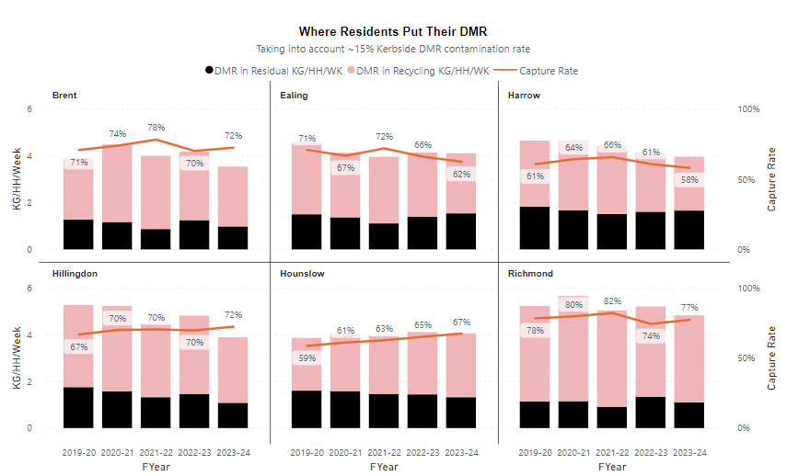
Appendix 4 – Borough capture rates – Green Waste
